**INFRA AUDITS - ANALYSIS REPORT GENERATTION**

PORJECT ID : 12

**NAME :** ASHWIN KARTHIK M **SEAT NO :** 297

**PROBLEM STATEMENT:**

Generate a portal to enter the

(i) details of auditable area

(ii) Task details

(iii) auditor details

(iv) observations

(v) Progress of action taken for the specific observation

(vi) Report proof with photo

(vii) Task approval status

**TECHNOLOGY USED:**

For this project I am using MERN stack,

|  |  |
| --- | --- |
| FORNT END | React JS |
| BACK END | Node JS , Express JS |
| DATABASE | MongoDB (No SQL) |
| API | Open API |

**IDEA PROPOSED:**

* **Weekly Audit Form**: Users fill out audit forms online, submitting results directly to the website.
* **Discrepancy Detection**: The system automatically identifies and highlights discrepancies, making them easily accessible to the administrator.
* **Task Assignment**: Issues identified during audits can be assigned to specific individuals. The system sends out automated emails to notify them of their tasks.
* **Task Status Page**: A dashboard or page where administrators can monitor the progress of assigned tasks, ensuring all issues are addressed.
* **Report Generation**: The application can generate reports on audit results, task status, and discrepancies. Reports can be customized by week, month, or a custom date range.

**PROJECT FLOWCHART:**

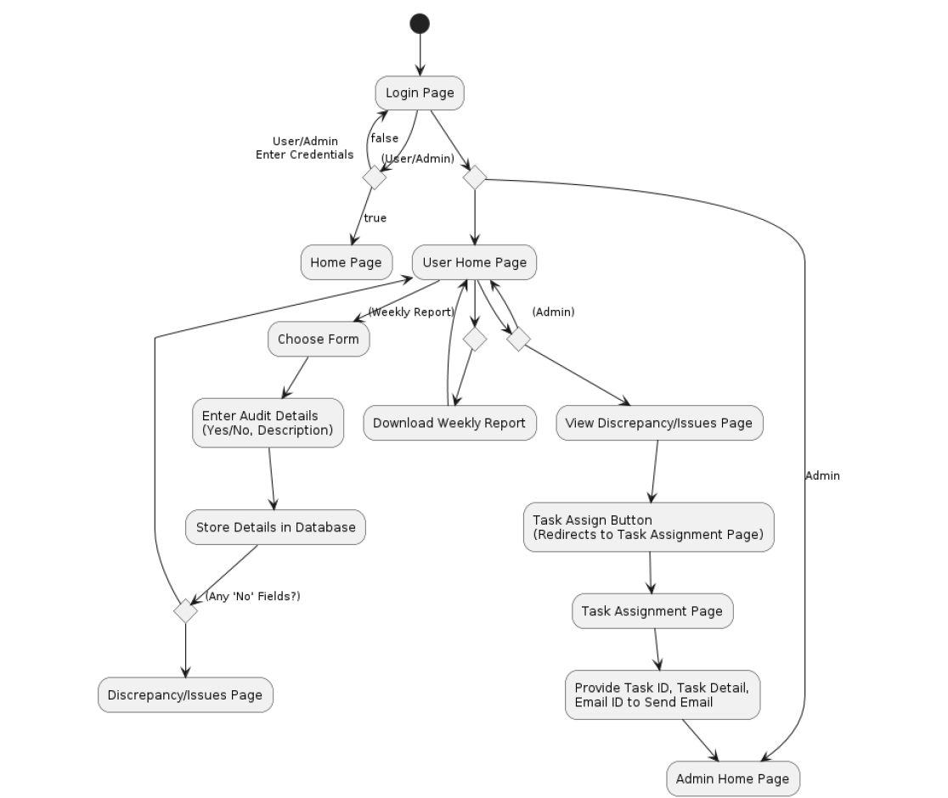

**WORK FLOW:**

* REQUIREMENT GATHERING
* IDEATION / IDEA GENERATION
* DESIGNING AUIDT FORMS AND LOGIN PAGES
* DATABASE CREATION
* CONFIGURING SERVER
* TESTING
* DEPLOYMENT

**PROTOTYPE PICTURES:**

